Department of Biochemistry

Report
SUMMER TRAINING PROGRAM
on
"Culturing, Maintenance and Experimentation with Drosophila melanogaster"
June 20 - July 15, 2022

The Department of Biochemistry, Shivaji College, University of Delhi (under the aegis of DBT Star College Scheme) organized Summer Training Program (STP) on "Culturing, Maintenance and Experimentation with Drosophila melanogaster" from June 20 - July 15, 2022. The organizers for this Summer Training Program were Dr. Jayita Thakur, Dr. Sunita Singh and Dr. Usha Yadav. More than 200 students had registered for the same, out of which 20 were selected. Students had a rigorous four-week training which included food preparation, culturing, cross set up, isolation & visualization of polytene chromosomes, gut pH profile among others pertaining to Drosophila melanogaster. They also presented the work done in the form of poster presentation. An elaborate report was submitted at the end. As a part of training program, students were taken for an educational visit to Prof. Surajit Sarkar’s Lab, Department of Genetics, University of Delhi on July 7, 2022. Details of the two popular lectures organized are as follows:
- Online Popular Lecture on “Drosophila: An Excellent Model For Understanding Human Biology, Development And Diseases” by Prof. S. C. Lakhotia, FNA, FASc, FNASc, Distinguished Professor (BHU), SERB Distinguished Fellow, Cytogenetics Laboratory, Department of Zoology, Banaras Hindu University, Varanasi 221 005, India on July 5, 2022.
- Lecture on “Drosophila melanogaster: an excellent system for identification and characterization of druggable targets against human neurodegenerative disorders” by Prof. Surajit Sarkar, Department of Genetics, University of Delhi, South Campus, New Delhi 110021, India on July 11, 2022.
To conclude the STP, Valedictory function was held on July 15, 2022 in the august presence of Prof. Alo Nag, Head of the Department, Department of Biochemistry, University of Delhi, South Campus. A total of 16 students successfully completed this training who were awarded certificate during valedictory session. It was concluded by the organizers with a vote of thanks.

List of the participants

Ms. Mitali Singh, B.Sc. (H) Biochemistry, Sem. IV, Shivaji College, University of Delhi
Ms. Pooja Gupta, B.Sc. (H) Biochemistry, Sem. IV, Shivaji College, University of Delhi
Ms. Vidisha Thakur, B.Sc. (H) Biochemistry, Sem. IV, Shivaji College, University of Delhi
Mr. Chander Parkash, B.Sc. (H) Biomedical Sciences, Sem. IV, Bhaskaracharya College of Applied Sciences, University of Delhi
Ms. Nandini S Nair, B.Sc. (H) Biochemistry, Sem. IV, Daulat Ram College, University of Delhi
Ms. Hitika, B.Sc. (H) Biochemistry, Sem. IV, Deshbandhu College, University of Delhi
Ms. Nandini, B.Sc. Life Sciences, Sem. IV, Hansraj College, University of Delhi
Ms. Divya Verma, B.Sc. (H) Biochemistry, Sem. IV, Institute of Home Economics, University of Delhi
Ms. Shreeja Sinha, B.Sc. (H) Biochemistry, Sem. IV, Institute of Home Economics, University of Delhi
Ms. Shalini Raman, B.Sc. (H) Zoology, Sem. IV, Sri Venkateswara College, University of Delhi
Ms. Harshita Gupta, B.Sc. (H) Biochemistry, Sem. IV, Shaheed Rajguru College of Applied Sciences for Women, University of Delhi
Ms. Shivapriya N Thilakan, B.Sc. (H) Biochemistry, Sem. IV, Institute of Home Economics, University of Delhi
Mr. Rohan Bhatia, B.Tech Biotechnology, Sem. VI, Netaji Subhas University of Technology
Ms. Arushi Gupta, B.Sc. (H) Biochemistry, Sem. IV, Sri Venkateswara College, University of Delhi
Ms. Ananya Tyagi, B.Sc. (H) Biochemistry, Sem. IV, Shaheed Rajguru College of Applied Sciences for Women, University of Delhi
Ms. Vanshika Tyagi, B.Sc. (H) Biochemistry, Sem. IV, Shaheed Rajguru College of Applied Sciences for Women, University of Delhi

Feedback form link: https://forms.gle/YToeFVWBn6qLcu7BA
PICS
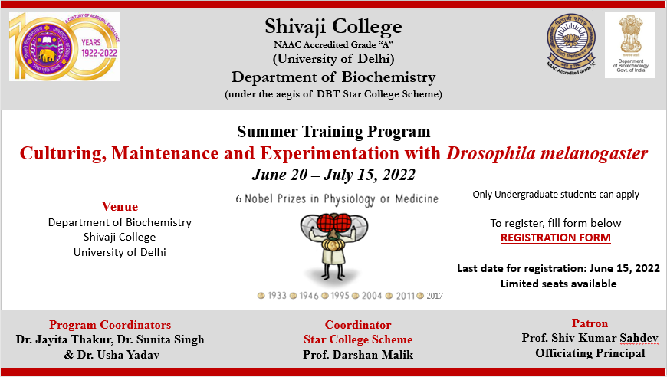

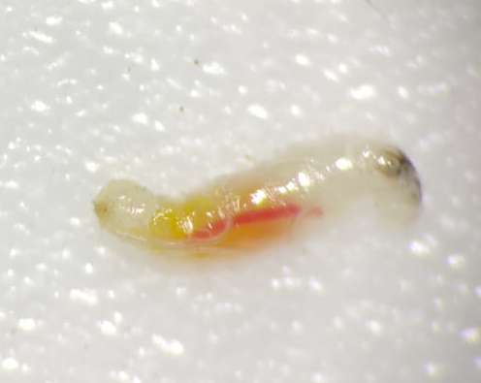
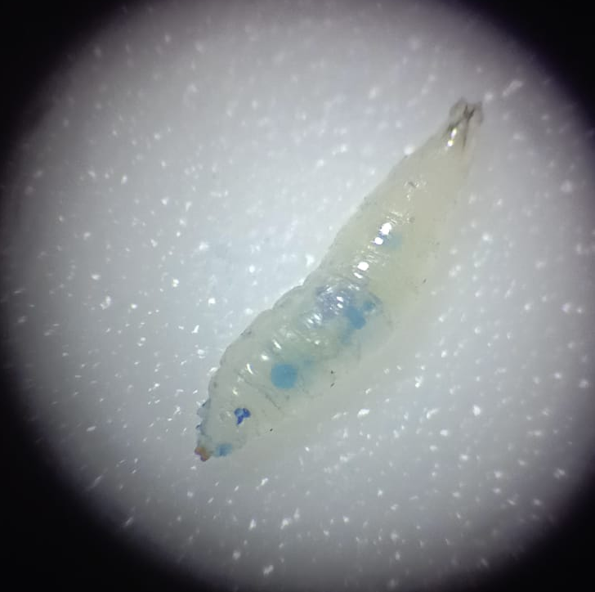
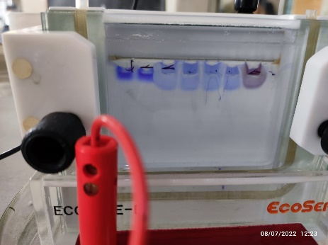

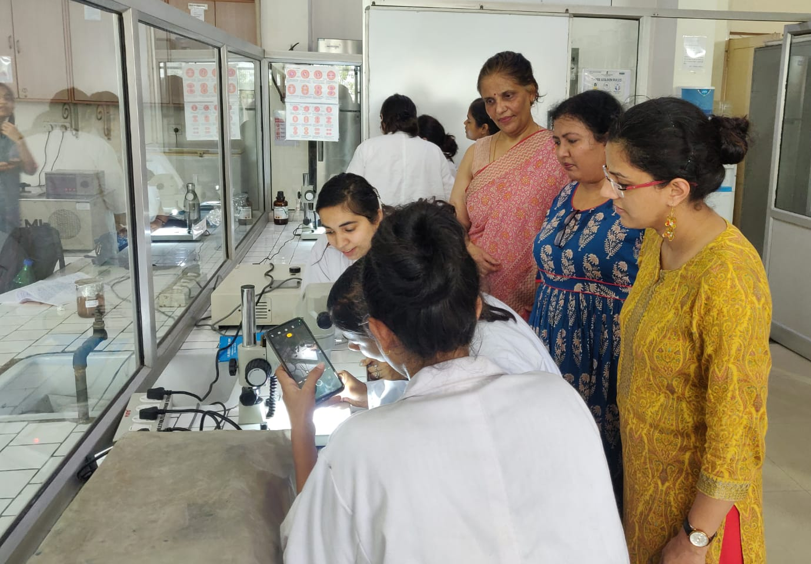

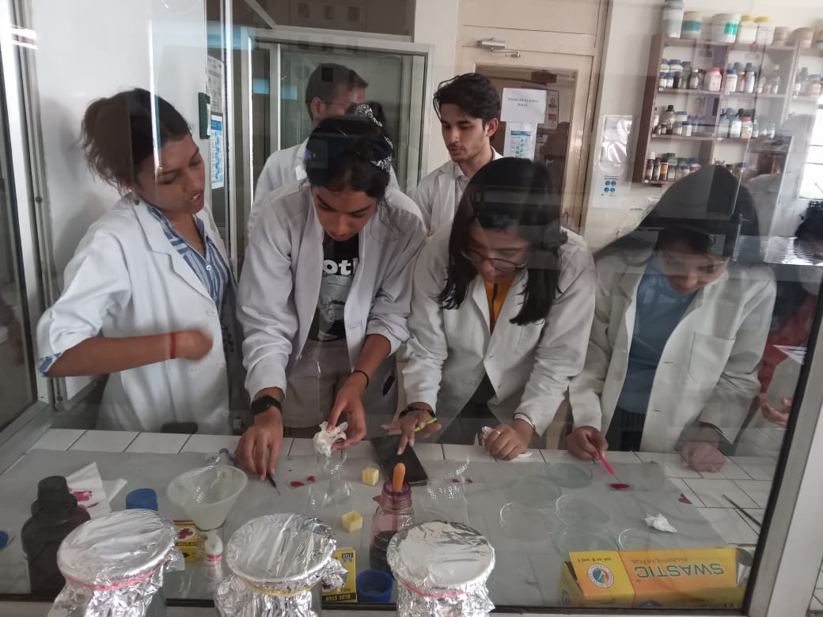
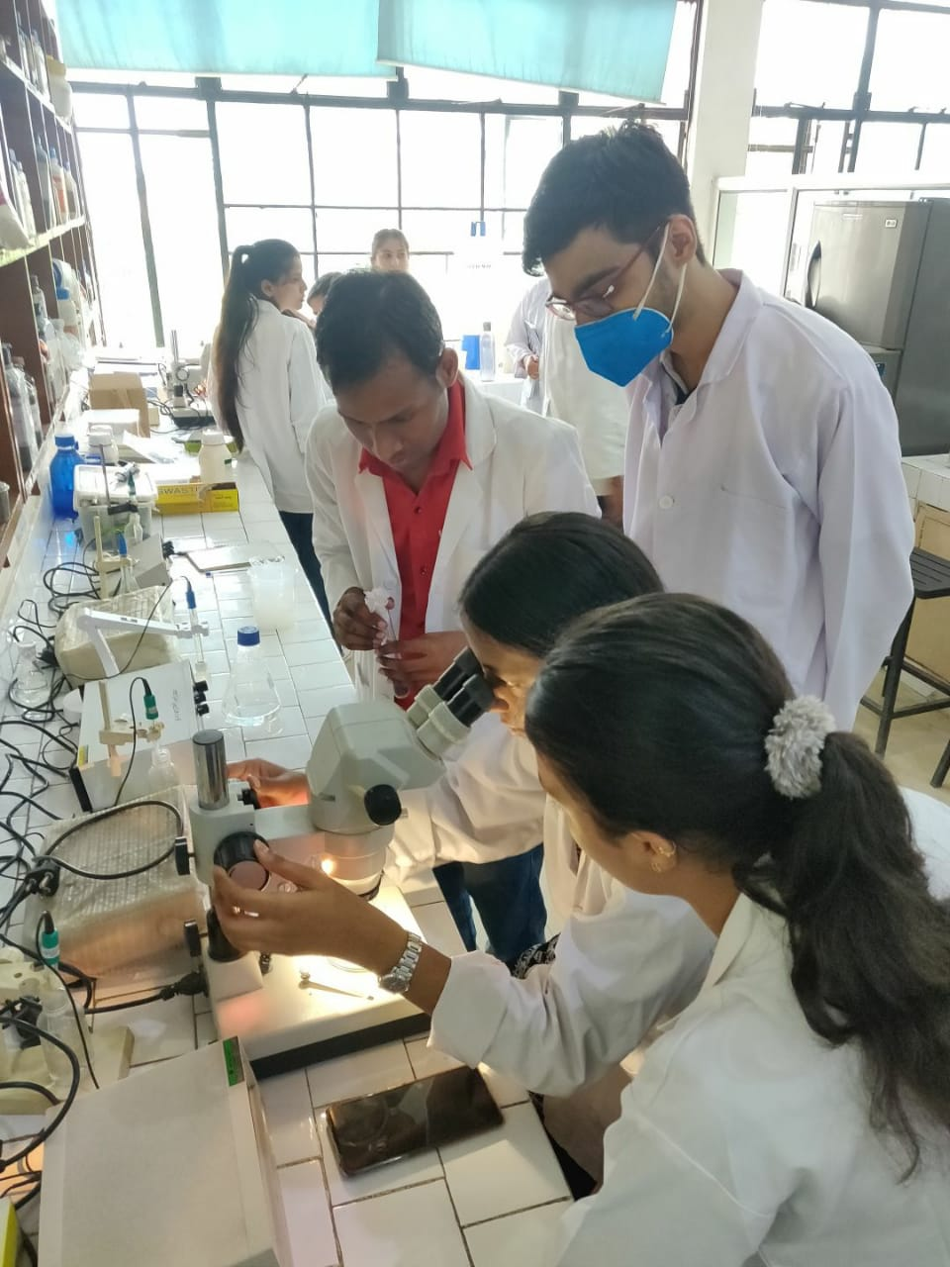

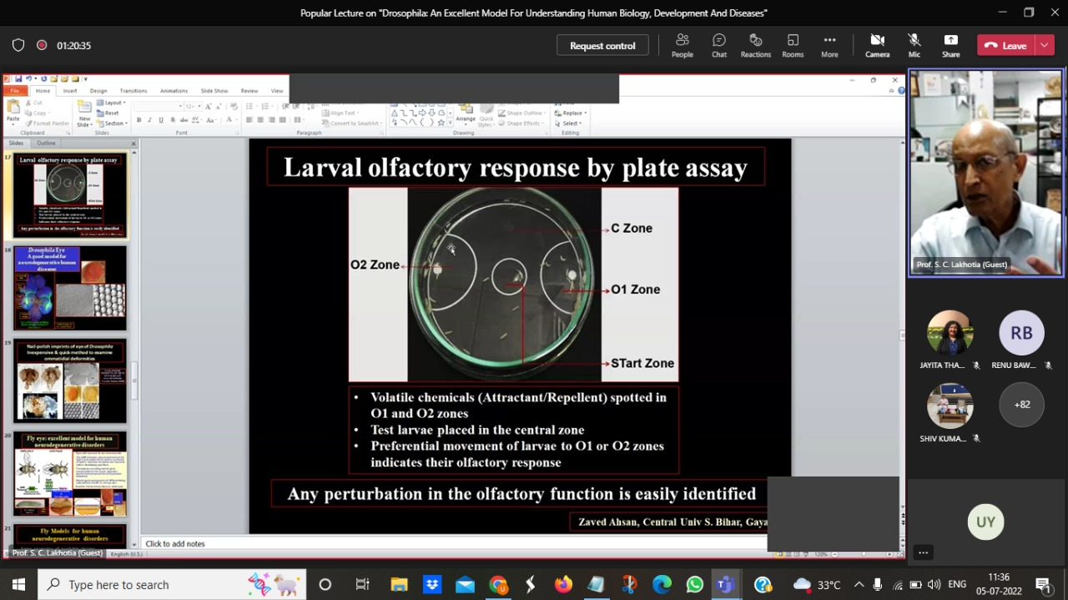

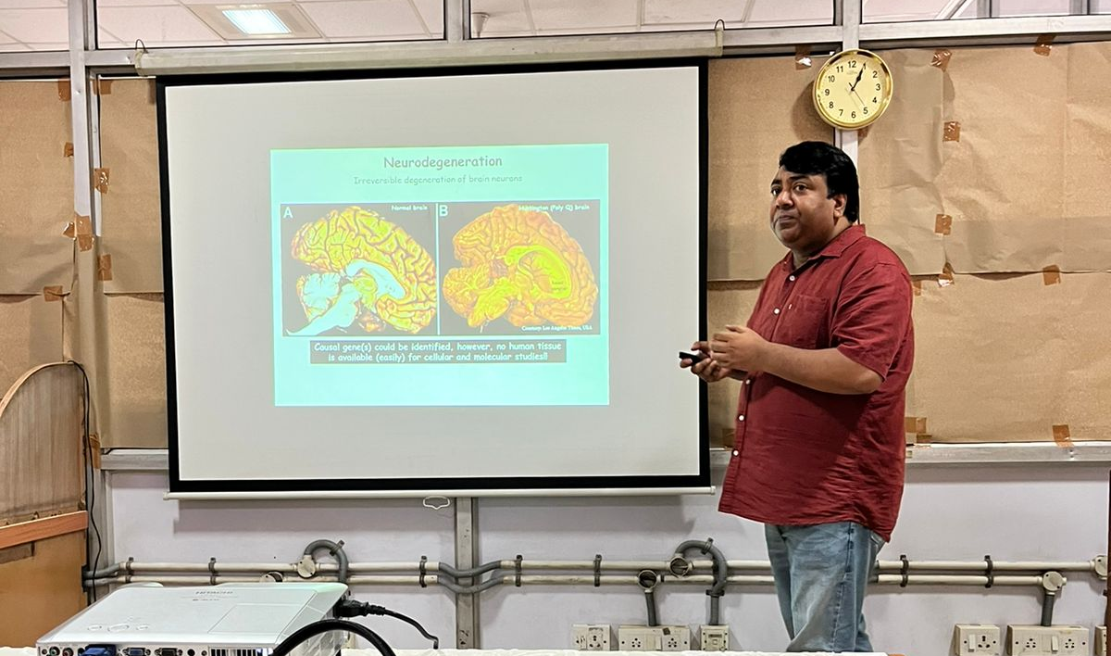

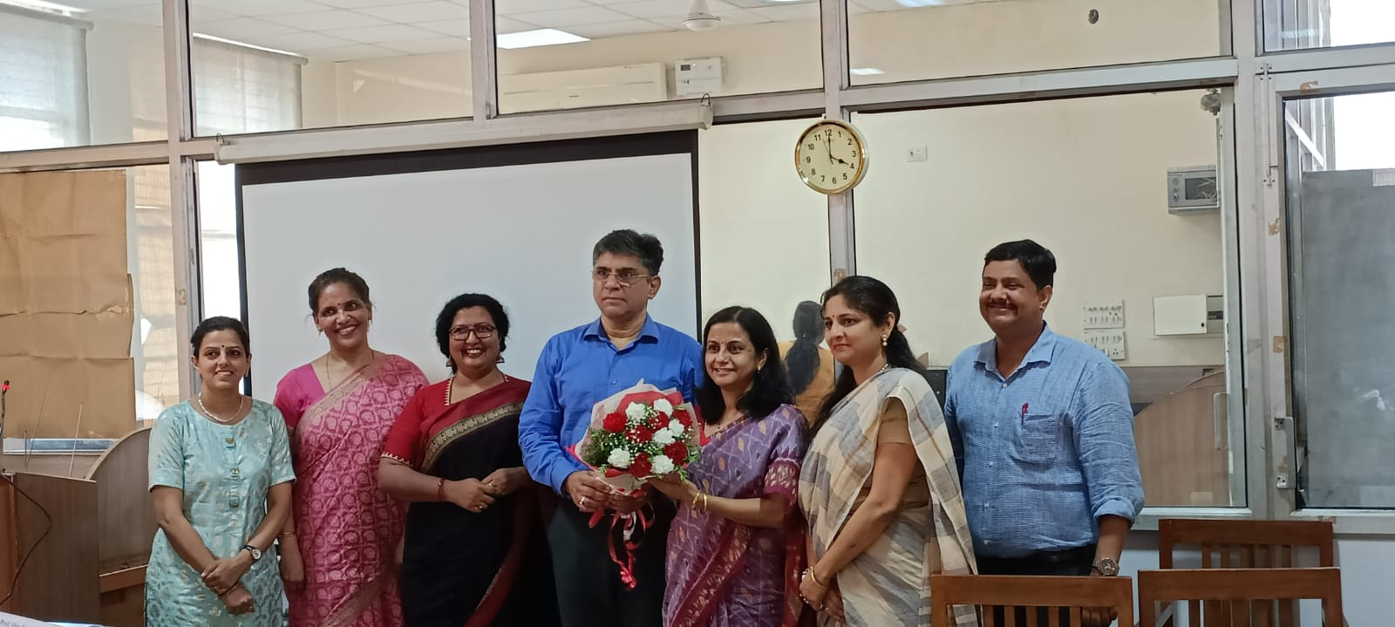
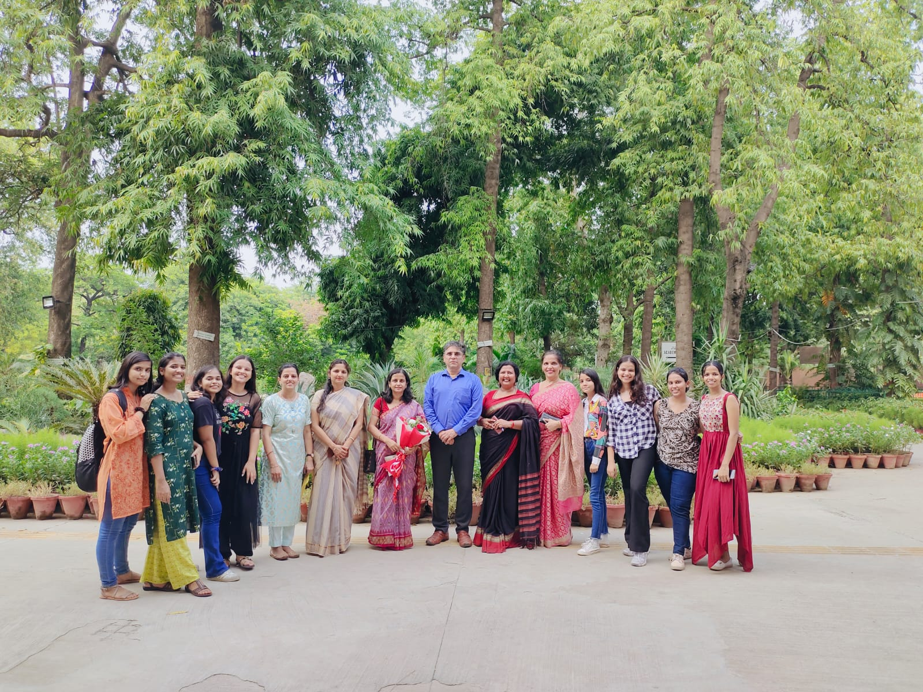

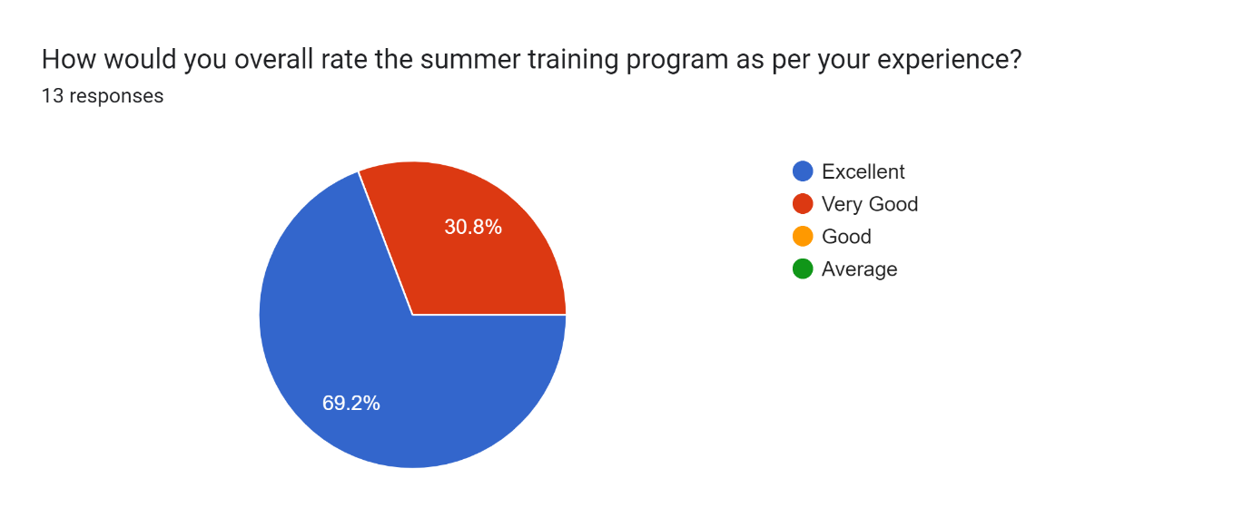

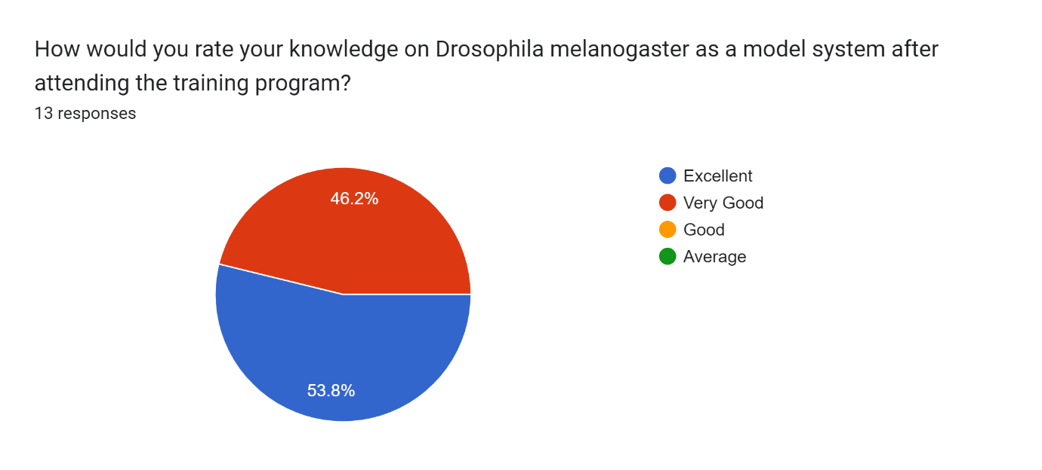
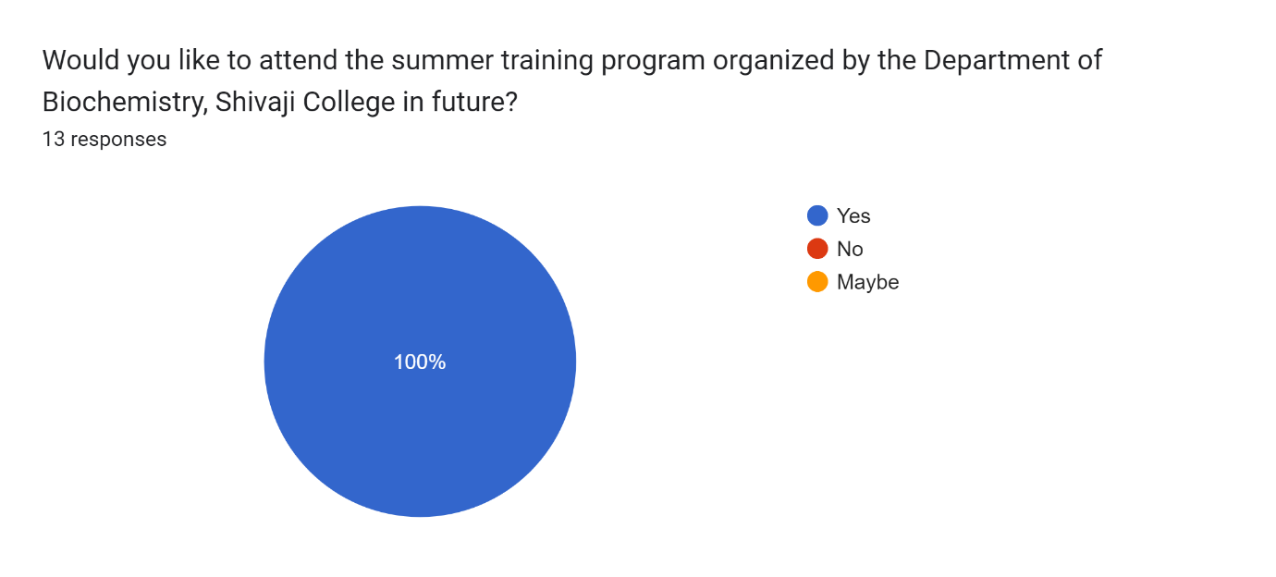

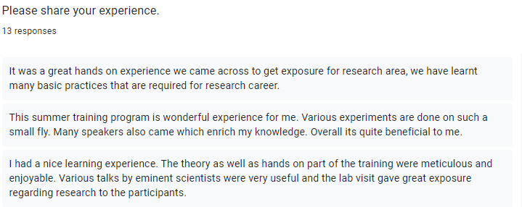

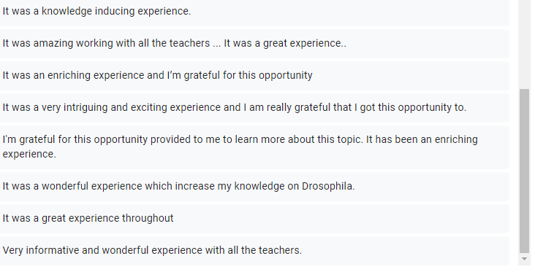

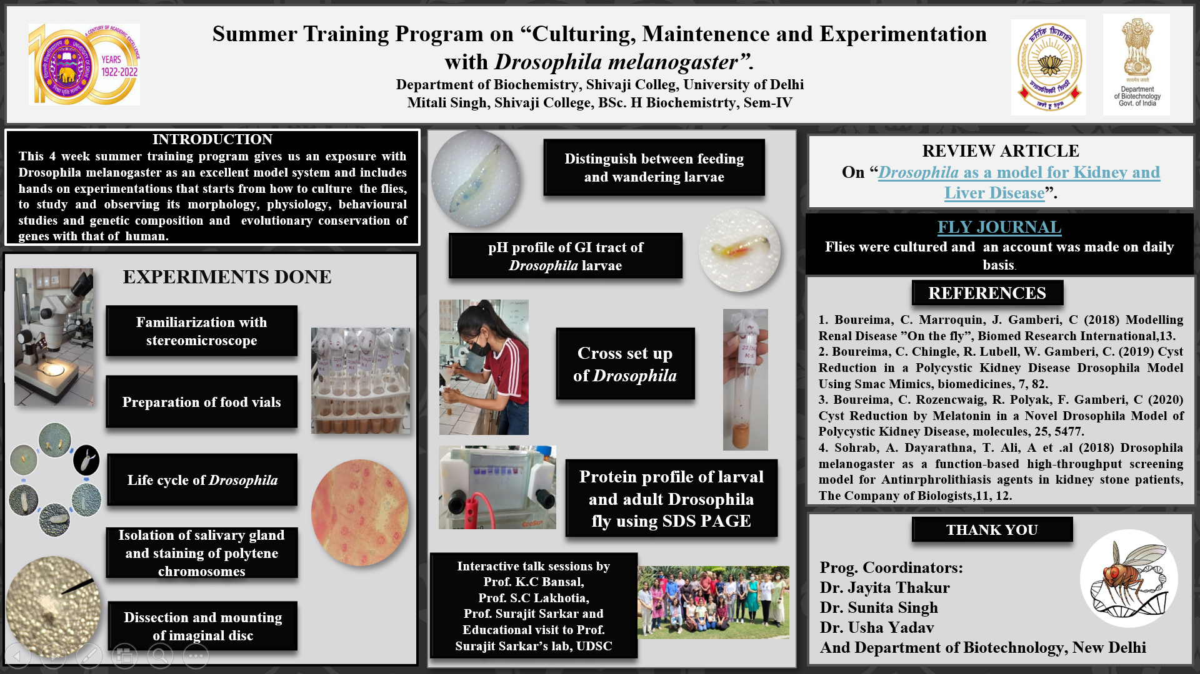

Shivaji College
(NAAC Accredited Grade “A”)
Department of Biochemistry
Summer Training Program 2022
(Under the aegis of DBT Star College Scheme)
Date : 8th July 2022
The Department of Biochemistry of Shivaji College Organised a four-week summer training program (STP) from 9th June - 8th July on the topic “Green Fabrication of Silver Nanoparticles and its Antibacterial Efficacy “. Thirteen students from different colleges were selected for the STP 2022. The four week STP was planned as follows:
Week 1- Screening of plants and Synthesis of AgNPs
Week 2- Purification of AgNPs
Week 3- Study of antimicrobial properties of AgNPs
Week 4- Project Report compilation and submission
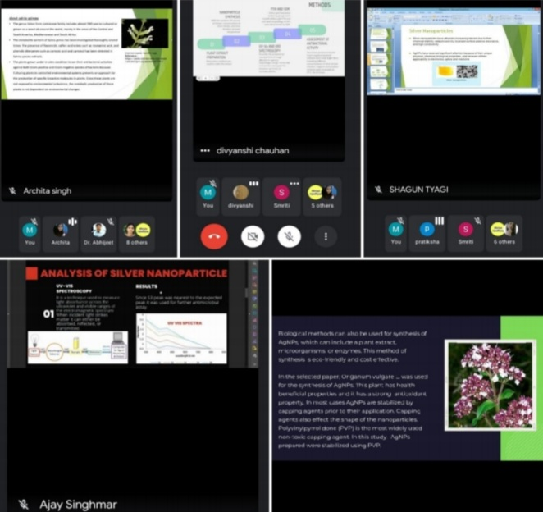
Total 13 students were selected from different colleges. During the STP, the students got exposure to different practical instruments and techniques involved in the synthesis and purification of nanoparticles. An online session was organised to support and enhance the Research paper reading skills among students. The students were asked to present any research paper on AgNPs synthesis and its antimicrobial properties. The session was organised on the google meet platform and the coordinators of the STP
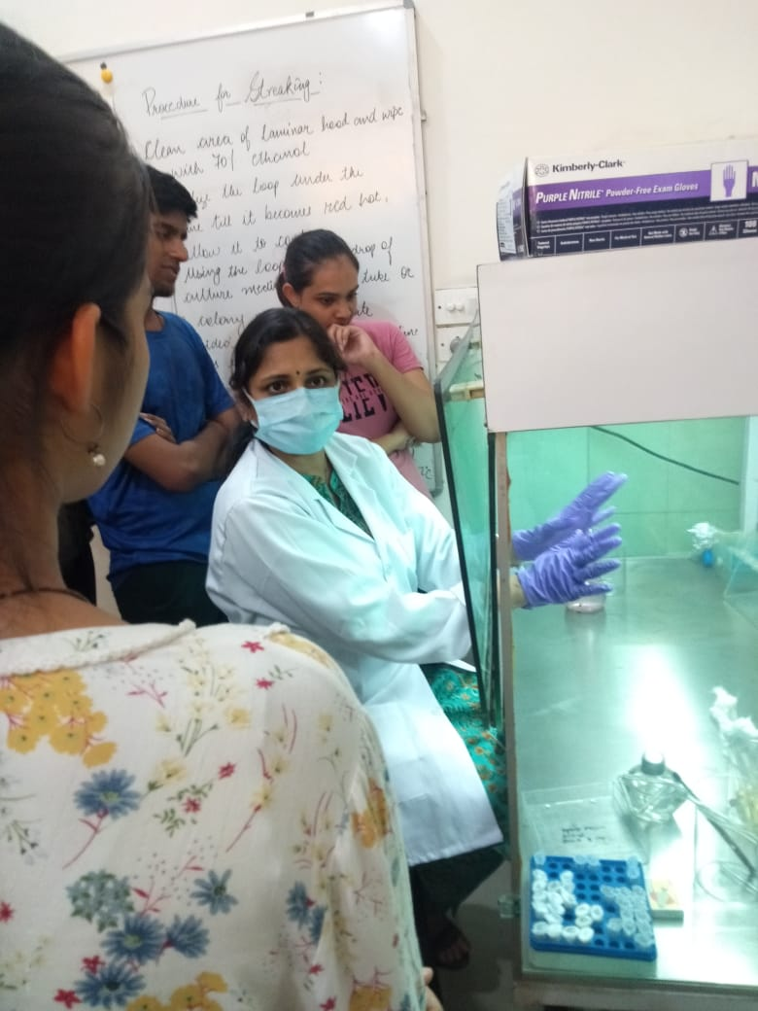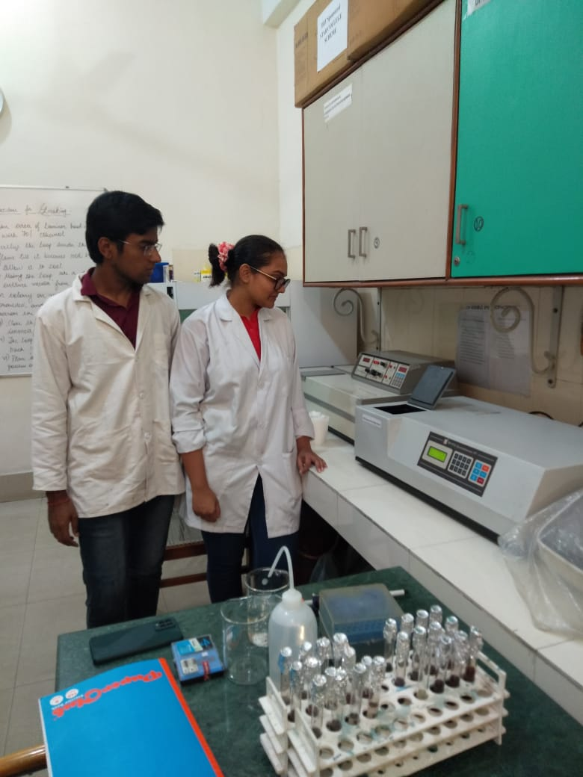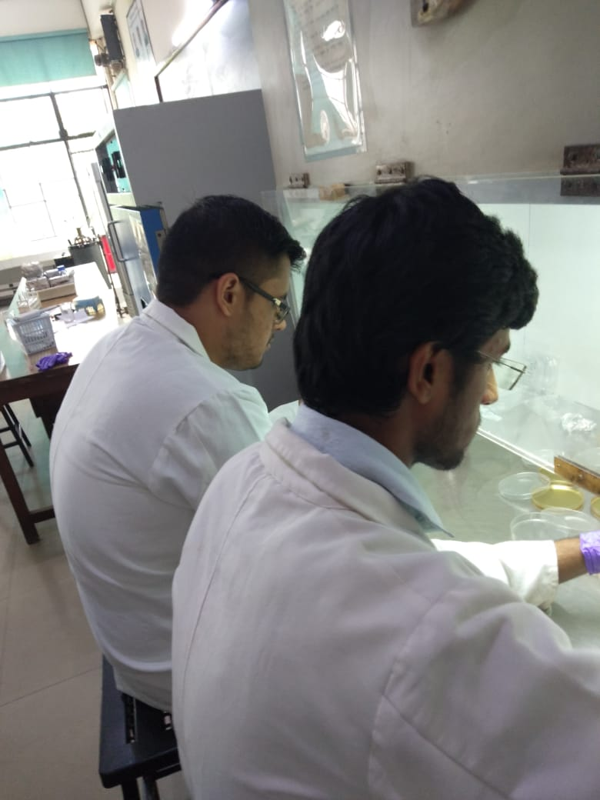

were also present. The students asked their query and the coordinators made it an interactive and healthy discussion.
In addition, Department of Biochemistry of Shivaji College also organized a scientific talk on “Unleaching the fundamentals of nanomaterials synthesis using Biological Cohorts” on the last day of the summer training program to mark a remarkable ending of the STP. Eminent scientist Dr. Anal Kant Jha, who is an associate professor and Coordinator of department of biotechnology, O.P Jindal University was the invited speaker. The talk was organized in virtual mode on MS teams platform at 2:00 p.m. He talked about several biological systems that can be used for synthesis of nanomaterials and also discussed the challenges one might face while doing so.
56 attendees were present during the talk including the students and faculty members of Shivaji college and various other colleges and universities. A large number of students pursuing their postgraduation and PhD in various allied fields were also present. The talk was interactive and was followed by a question and answer session, where students and the faculty members cleared their doubts and Dr. Anal answered every question asked during the talk. The students asked the questions with great enthusiasm and showed their interest in the topic. The feedback of the attendees were taken by google form.
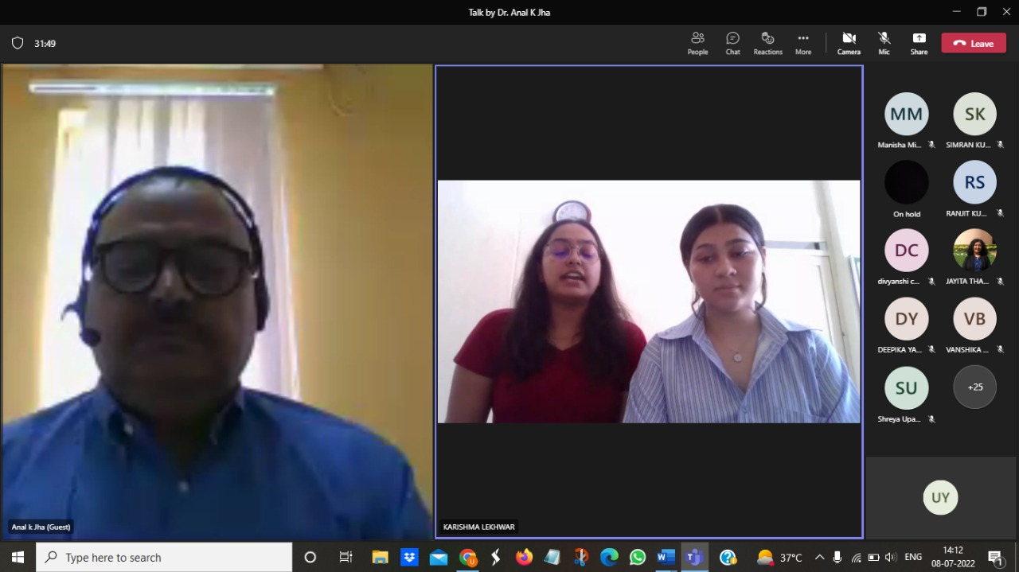
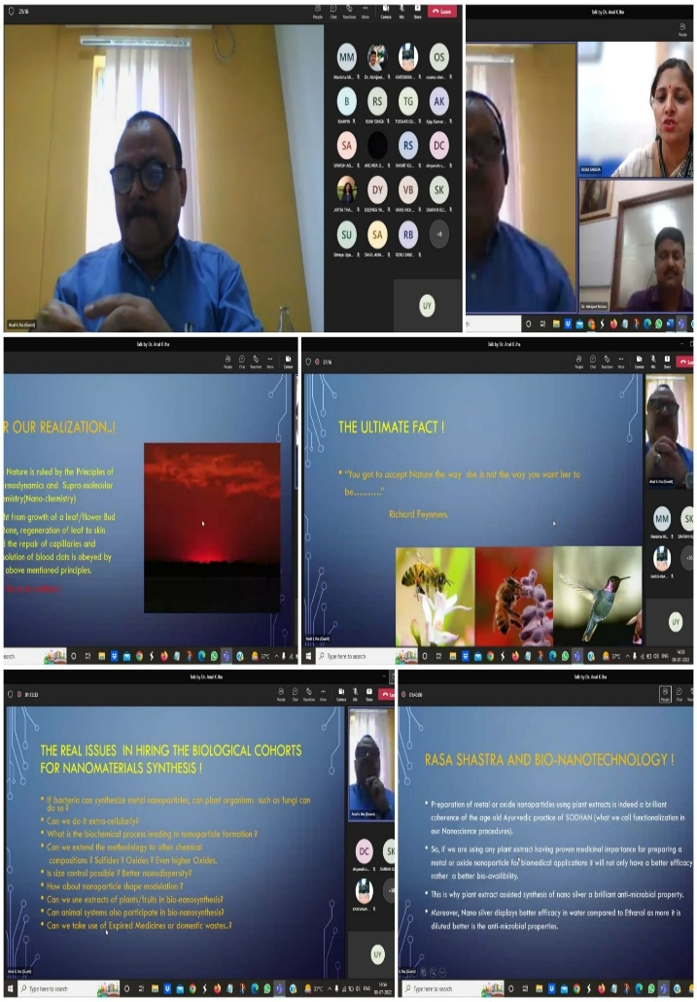

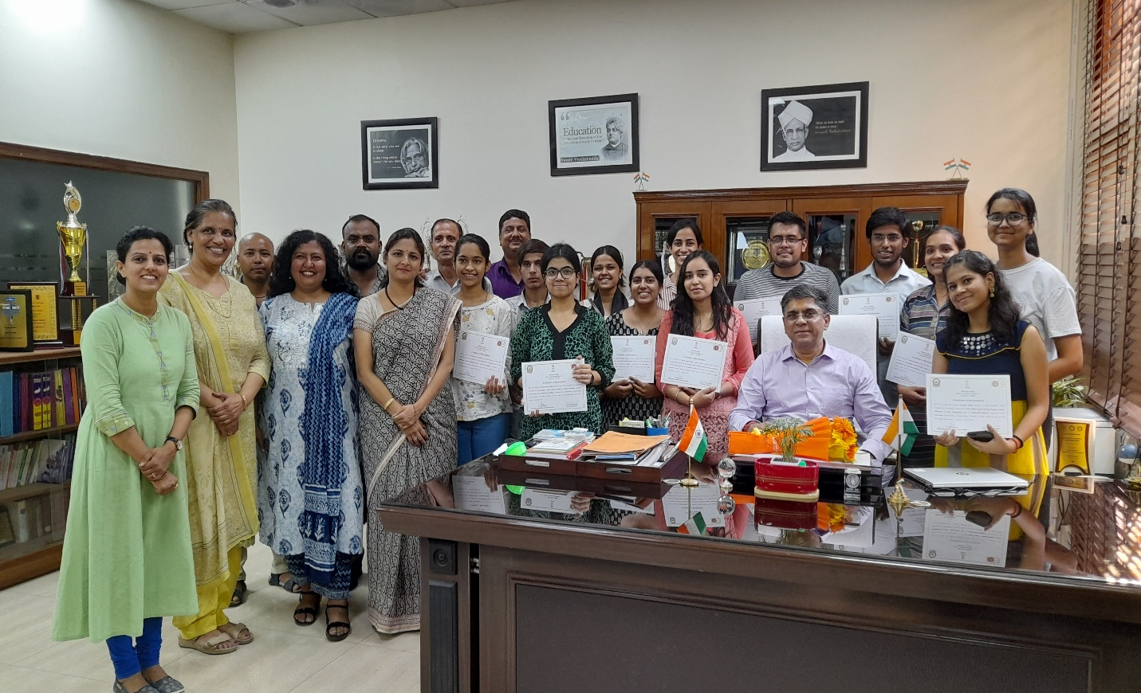
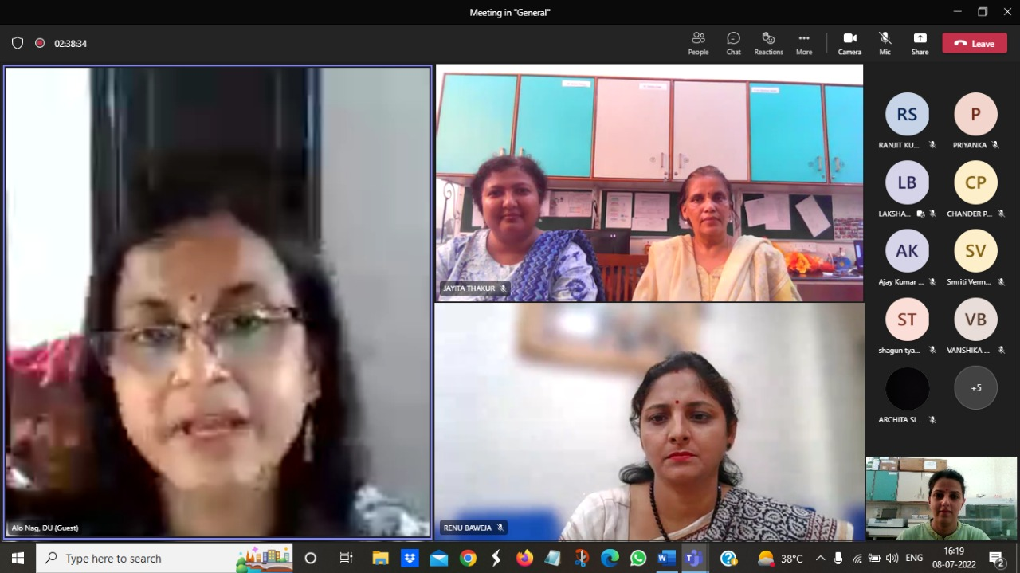
An E- certificate was awarded to all the participants of the talk. The talk was followed by the valedictory session of the STP. All the students shared their feedback through a short video message. Prof. Alo Nag , head of the Department of Biochemistry, University of Delhi, South Campus was invited as the chief guest. She hailed the work done by students, coordinators as well as the laboratory staff members of the college. She wished best of luck to all the participants. She also motivated students with her important messages. The principal of Shivaji college awarded certificate to the participants of STP and gave his blessings to the students.

1 | Shreya Malik | Shivaji College | Semester-IV
2 | Archita Singh | Shivaji college, Delhi University | Semester-IV
3 | Pratiksha Tiwari | Institute of Home Economics, | Semester-IV
4 | Shagun Tyagi | Institute of home economics, Delhi University | Semester-IV
5 | Dakshita Sehrawat | Shivaji College, University of Delhi | Semester-IV
6 | Vaibhav | Kirori Mal College, Delhi University | Semester-IV
7 | Smriti Verma | Gargi College, University of Delhi | Semester-IV
8 | Divyanshi Chauhan | Gargi College, University of Delhi | Semester-IV
9 | Ajay Kumar Singhmar | Acharya Narendra Dev College University Of Delhi | Semester-IV
10 | Mehfooz Helal | Shivaji College, University of Delhi | Semester-IV
11 | Kinjal Jain | Kirori Mal College DU | Semester-IV
12 | Manas Singhal | Acharya Narendra Dev College, University of Delhi | Semester-IV
13 | Shreya Upadhyay | Deen Dayal Upadhyaya College, Delhi University | Semester-IV

Department of Botany
Shivaji College, Star College Scheme
Summer Training program on
“Innovative Natural Resource Management Technologies for Youth”
from June 20- July 18, 2022

Department of Botany, Shivaji College had organized a month-long Summer Training Internship Programme under the aegis of DBT Star College Scheme, entitled "Innovative Natural Resource Management Technologies for Youth" from June 20- July 18, 2022.
For the inaugural session, the key note address was delivered by Prof. K. C. Bansal, Secretary, National Academy of Agricultural Sciences, India and Former Director of NBPGR, ICAR, Pusa, New Delhi. Thereafter, for the next two days renowned dignitaries: Prof. Dinabandhu Sahoo, Senior Professor, Department of Botany, University of Delhi and Prof. Dr Atul, Freelance Consultant, Director (Rtd.) Directorate of Extension Education & Founder HOD Department of Agroforestry & Organic Agriculture CSK-HP Agricultural University, Palampur, Himachal Pradesh, graced the event. Eight more dignitaries, Dr. Neelam Sharma, Dr. Pratibha Brahmi, Dr. Reshma Gills, Dr. Shivendra Kumar Srivastava, Dr. Anuja Gupta, Dr. Ashwani Kumar, Dr. Manoj Kumar Singh and Dr. Sumit Sahni, along with the thirteen in-house faculty, also joined as resource persons. The schedule spanned areas pertaining to the role of Biotechnology, Genetic Engineering, Conservation technologies and strategies, Agroforestry, Seed Technology, Regulatory and policy issues related to access and use of biological resources for research, conservation social science, herbarium techniques, role of sequencing and bioinformatics about sequence retrieval, nucleotide data base, ORF, homology test BLAST, applications of plant tissue culture and green belt and its aesthetics.
The key highlights of the event were the four trips providing experiential learning giving students exposure to world class facilities. Students were taken for visit to the extension centre and various departments of CSK Himachal Pradesh Krishi Vishwavidyalaya (HPKV, Palampur) and Institute of Himalayan Bioresource Technology (IHBT Palampur); ICAR- Indian Agriculture Research Institute, Pusa, New Delhi; ICAR- National Bureau of Plant Genetic Resources; mushroom cultivation facility at the Acharya Narendra Dev College, University of Delhi.
No. of Students Registered – 69
No. of Student Beneficiaries – 37

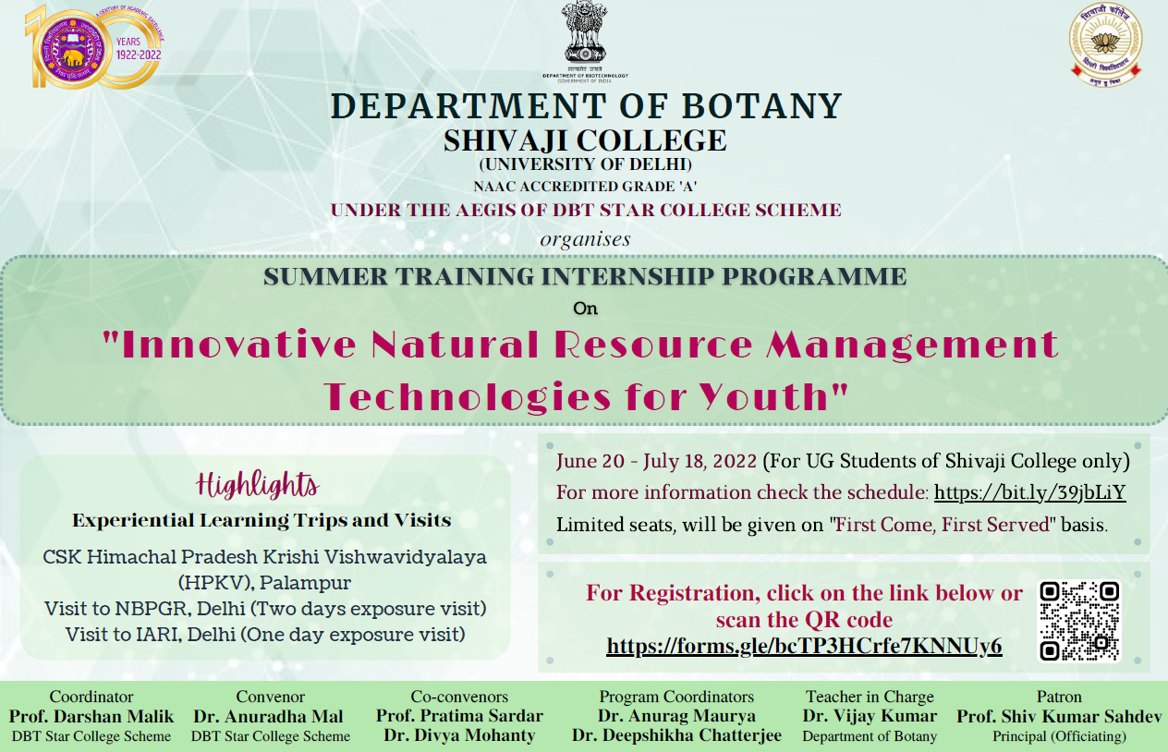
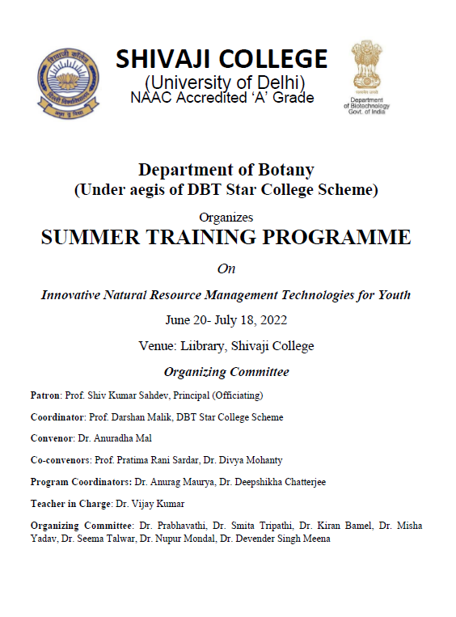

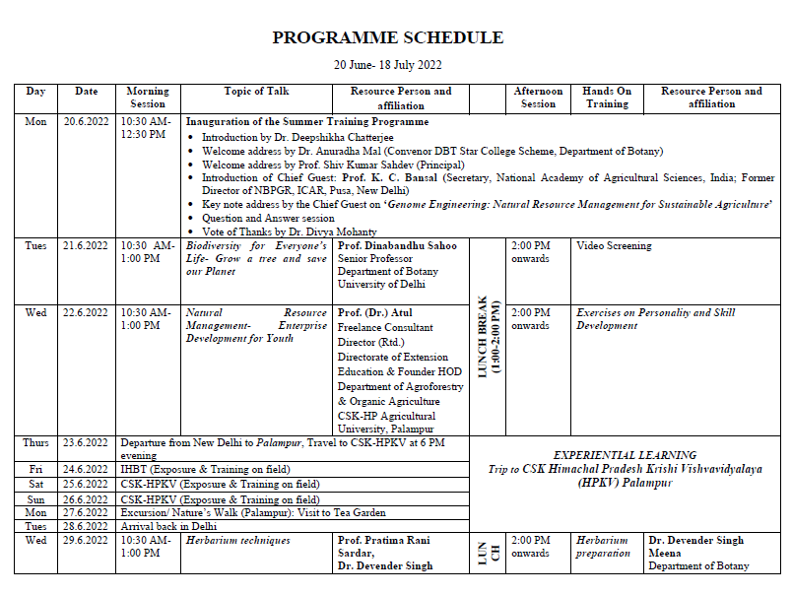
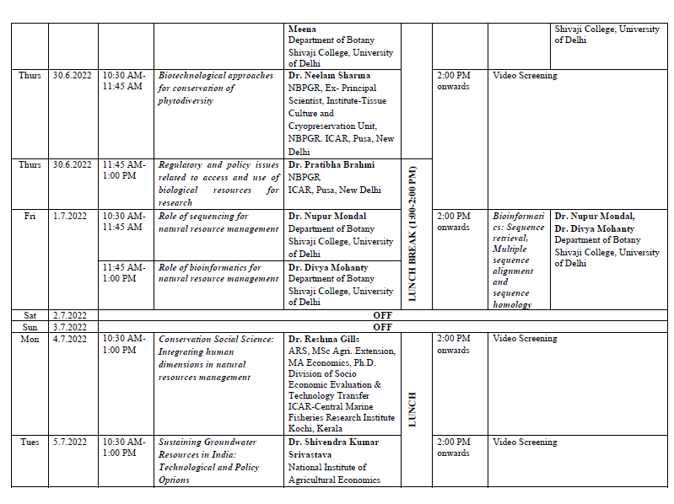

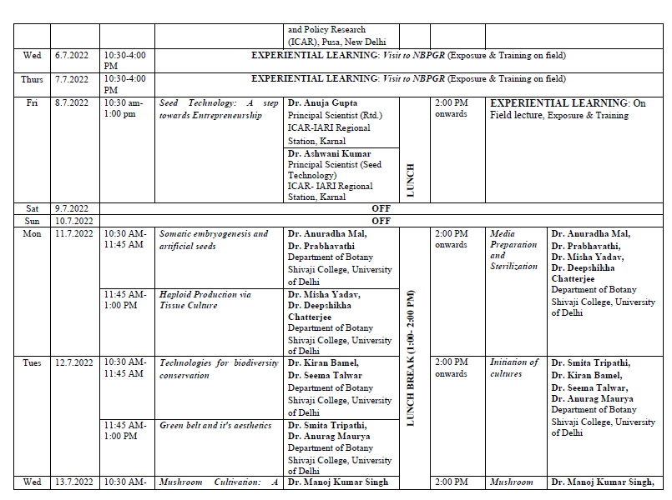
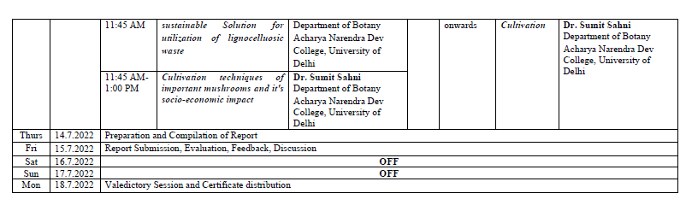
- External Resource Persons
S. No. | Resource Person Name | Affiliation
1 | Prof. K. C. Bansal | Secretary, National Academy of Agricultural Sciences, India; Former Director of NBPGR, ICAR, Pusa, New Delhi
2 | Prof. Dinabandhu Sahoo | Senior Professor, Department of Botany, University of Delhi
3 | Prof. (Dr.) Atul | Freelance Consultant, Director (Rtd.), Directorate of Extension Education & Founder HOD Department of Agroforestry & Organic Agriculture CSK-HP Agricultural University, Palampur
4 | Dr. Neelam Sharma | NBPGR, Ex- Principal Scientist, Institute-Tissue Culture and Cryopreservation Unit, NBPGR. ICAR, Pusa, New Delhi
5 | Dr. Pratibha Brahmi | NBPGR , ICAR, Pusa, New Delhi
6 | Dr. Reshma Gills | ARS, MSc Agri. Extension, MA Economics, Ph.D., Division of Socio-Economic Evaluation & Technology Transfer  ICAR-Central Marine Fisheries Research Institute Kochi, Kerala
7 | Dr. Shivendra Kumar Srivastava | National Institute of Agricultural Economics and Policy Research (ICAR), Pusa, New Delhi
8 | Dr. Anuja Gupta | ICAR-IARI, Principal Scientist (Rtd.)  Regional Station Karnal
9 | Dr. Manoj Kumar Singh | Department of Botany, Acharya Narendra Dev College, University of Delhi
10 | Dr. Sumit Sahni | Department of Botany, Acharya Narendra Dev College, University of Delhi

- Total No. of Participants Enrolled in Summer Internship Programme
S. No. | Name of Students | Course and year
 | Anjali Mittal | B.Sc. (Hons.) Botany, 2nd Year
 | Shivani Thakur | B.Sc. (Hons.) Botany, 2nd Year
 | Khushi Vats | B.Sc. (Hons.) Botany, 2nd Year
 | Sumit Kumar Pathak | B.Sc. (Hons.) Botany, 2nd Year
 | Yamini | B.Sc. (Hons.) Botany, 2nd Year
 | Mona Patel | B.Sc. (Hons.) Botany, 2nd Year
 | Kartikeya Tiwari | B.Sc. (Hons.) Botany, 2nd Year
 | Anjali | B.Sc. (Hons.) Botany, 2nd Year
 | Kanishka Goyal | B.Sc. Life Sciences, 2nd Year
 | Charulata Joshi | B.Sc. Life Sciences, 2nd Year
 | Vishakha | B.Sc. Life Sciences, 2nd Year
 | Himanshu | B.Sc. (Hons.) Botany, 2nd Year
 | Nisha | B.Sc. (Hons.) Botany, 2nd Year
 | Gyanendra Ranjan | B.Sc. Life Sciences, 2nd Year
 | Nishant | B.Sc. Life Sciences, 2nd Year
 | Udayveer | B.Sc. Life Sciences, 2nd Year
 | Abhilasha Shekhawat | B.Sc. Life Sciences, 2nd Year
 | Millee | B.Sc. Life Sciences, 2nd Year
 | Khursheed Alam | B.Sc. Life Sciences, 2nd Year
 | Yashashvi Sahu | B.Sc. Life Sciences, 2nd Year
 | Mayank | B.Sc. Life Sciences, 2nd Year
 | Purnima Maurya | B.Sc. Life Sciences, 1st Year
 | Alok Kumar | B.Sc. Life Sciences, 1st Year
 | Gunjan Yadav | B.Sc. Life Sciences, 1st Year
 | Harshita Yadav | B.Sc. Life Sciences, 1st Year
 | Kritika | B.Sc. Life Sciences, 1st Year
 | Veenita Yadav | B.Sc. Life Sciences, 1st Year
 | Samarth Arora | B.Sc. Life Sciences, 1st Year
 | Akanksha | B.Sc. Life Sciences, 1st Year
 | Kanishka | B.Sc. Life Sciences, 1st Year
 | Neha | B.Sc. Life Sciences, 1st Year
 | Tanu | B.Sc. Life Sciences, 1st Year
 | Meghna Singh Chauhan | B.Sc. (Hons.) Botany, 1st Year
 | Anurita | B.Sc. (Hons.) Botany, 1st Year
 | Manisha | B.Sc. (Hons.) Botany, 1st Year
 | Kanak Bhardwaj | B.Sc. (Hons.) Botany, 1st Year
 | Saniya Praveen | B.Sc. (Hons.) Botany, 1st Year

Feedback
Kanak Bhardwaj (B.Sc. (H) Botany, 1st year) - First of all I would like to thank all teachers who arrange this internship and I am very glad to be a part of it. From this summer training I have learned many things it was a complete whole new experience for me. We got to interact with many new people and got to know about them, their work, more to this field and many things. Even the trip, I am happy that I could go because I enjoyed every part of it. Moreover, we got to link with our teachers and friends more. Thank you for holding this summer training for us.
Shivani Thakur (B.Sc. (H) Botany, 2nd year) - The summer internship was very nice and very helpful. I got to know about various new technologies like phytotron that I was not aware of. I had seen the methods and techniques like tissue culture, hydroponics, mushroom cultivation, protected agriculture, tea making technique, cryopreservation, integrated farming, vermicomposting and many more with my own eyes that I had seen only in books or the internet. I also did bag and it was a great experience. I get an opportunity to meet with many scientists and experts. One of the best experiences I have ever encountered. I am really glad that I did it.
Mille Chandaulla (B.Sc. Life Sci, 2nd year) - The summer internship organised by the department of botany and DBT was very helpful and educational. We got to learn so much more than just theory. The exposure trips were too good and beneficial and we got practical knowledge. And it will definitely help us in future. In short, the overall experience was good and educational. Thankyou!

Khursheed (B.Sc. Life Sci, 2nd year) - It was a very interesting experience for me as I learned different aspects in conserving the natural resources. I had a great experience with NBPGR and IARI, Pusa New Delhi. Mushroom cultivation technique and how we can use lignocellulosic waste was very innovative for me. The eminent professors like Prof. Dinabandhu Sahoo, Prof. Dr. Atul and many others were very great teachers they taught us about different topics rather than academics which gave me numerous ideas to grow and learn. The summer training program was very innovative for me. I would like to thank DBT for scheduling such an amazing program.

Anjali Mittle (B.Sc. (H) Botany, 2nd year) - The session was very informative. We have learnt so many new things other than our course. In 1 month internship we met many great professors who is very kind, polite, and very knowledgeable. Open communication was one of the strongest and most apparent skills. I am also obliged to resource person who demonstrated experiments/techniques/research work at Palampur, CSK Himachal Pradesh, ICAR, NBPGR.

Tanu ((B.Sc. Life Sci, 2nd year) - I must say it was a great experience for me after getting enrolment in this summer training program. It was really great. After pursuing it a have gone through so much of new and wonderful experiences, many hands-on experiences. We get the opportunities to visit those great institutions that are doing so great work, there we got lots of information about many new things in the field of botany and also got a great opportunity to learn from the great scientists there.
We get into various aspects of a particular topic which we think is just too small field/topic.
I am very thankful to our teachers those make this training possible and in a smooth and best way. And a special thanks to star DBT for making this possible. It was such a great experience and a great exposure for me.

Sumit Pathak (B.Sc. (H) Botany, 2nd Year) – This summer training Program was indeed very Fruitful, visit to the extension centre and various departments of CSK Himachal Pradesh Krishi Vishwavidyalaya (HPKV, Palampur) and Institute of Himalayan Bioresource Technology (IHBT Palampur) gave us opportunity to learn various aspects of tissue culture techniques, different advance tools and techniques used in molecular biology, Biochemistry and biotechnology. Various techniques used in Organic Agriculture and Horticulture. Brief Description about Soil Physics and Seed Technology. Industrial Visit to Tea Husbandry Unit to learn various Techniques used in Tea Processing. Field Excursion and Herbarium techniques along with Museum comprising of all information regarding Himachal Pradesh such as soil structure and texture, soil fertility, fodder seeds, diseases and tradition. Attending this training Definitely provided an upper edge.

Shivaji College
Star College Scheme
Department of Chemistry
Summer Training
on
“Analytical Tools and Techniques”
from 20.06.2022 to 17.07.2022

Convenor: Dr. P. K. Sahu
Co-Convenor: Dr. Richa Arora

Report
In the inter-college summer training spanning four weeks, 129 students of B.Sc (H) Chemistry, Botany, Zoology, Biochemistry, Industrial Chemistry, Biomedical Science, B.Sc (P) Life Sciences, and B.Sc (P) Physical Sciences with Chemistry from different colleges of University of Delhi participated. Students learnt some of the analytical techniques like distillation, solvent extraction, flame photometry and column chromatography and performed short exercises using these techniques and submitted reports at the end of training.

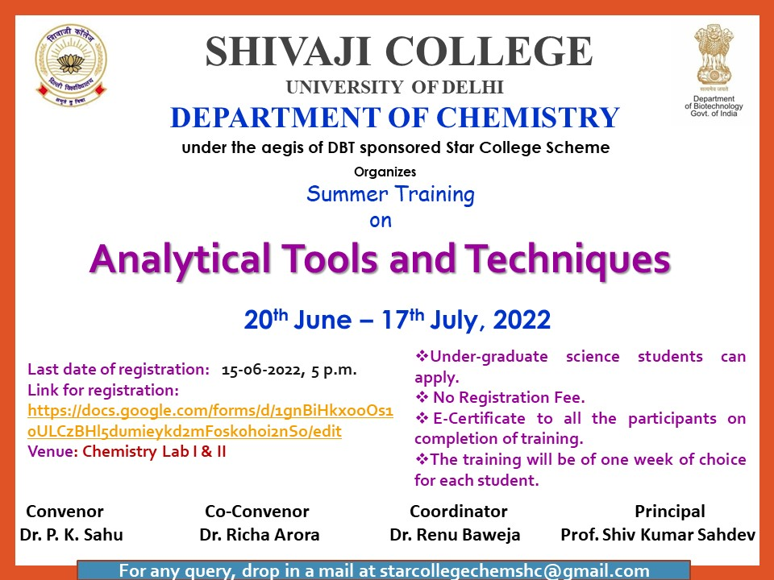
Poster

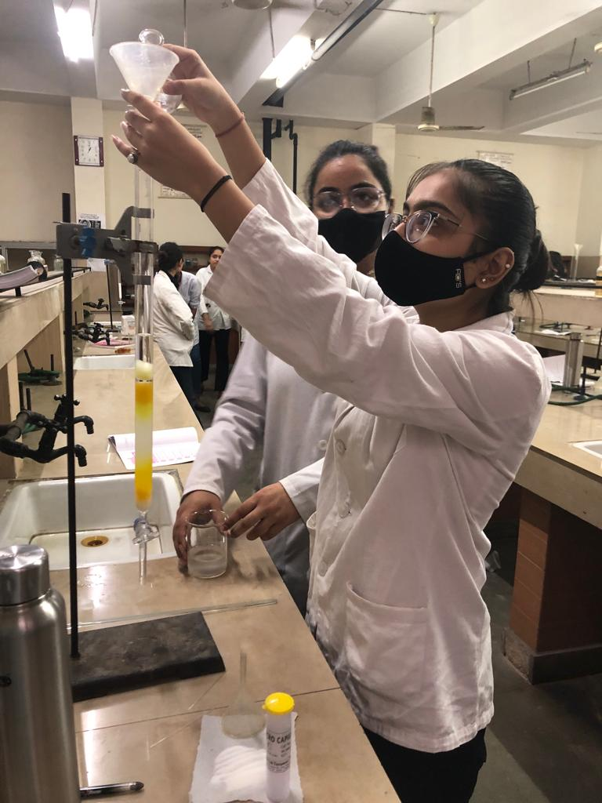
Students working on Column Chromatography technique
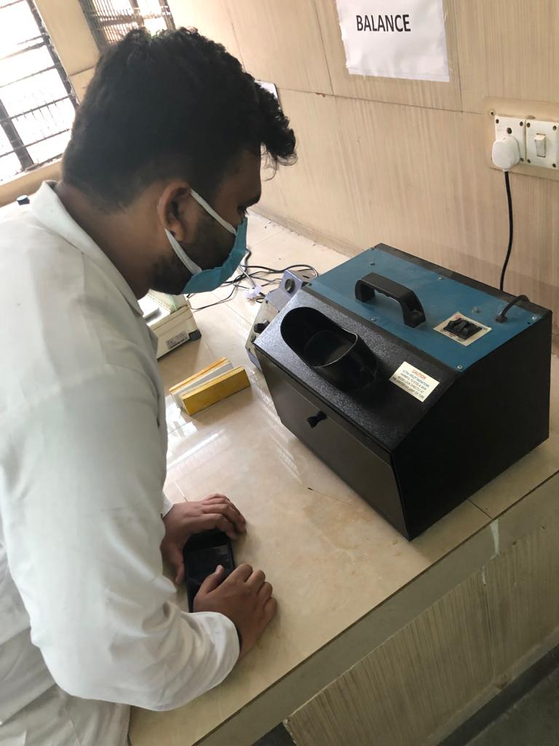
Student analyzing sample in UV chamber
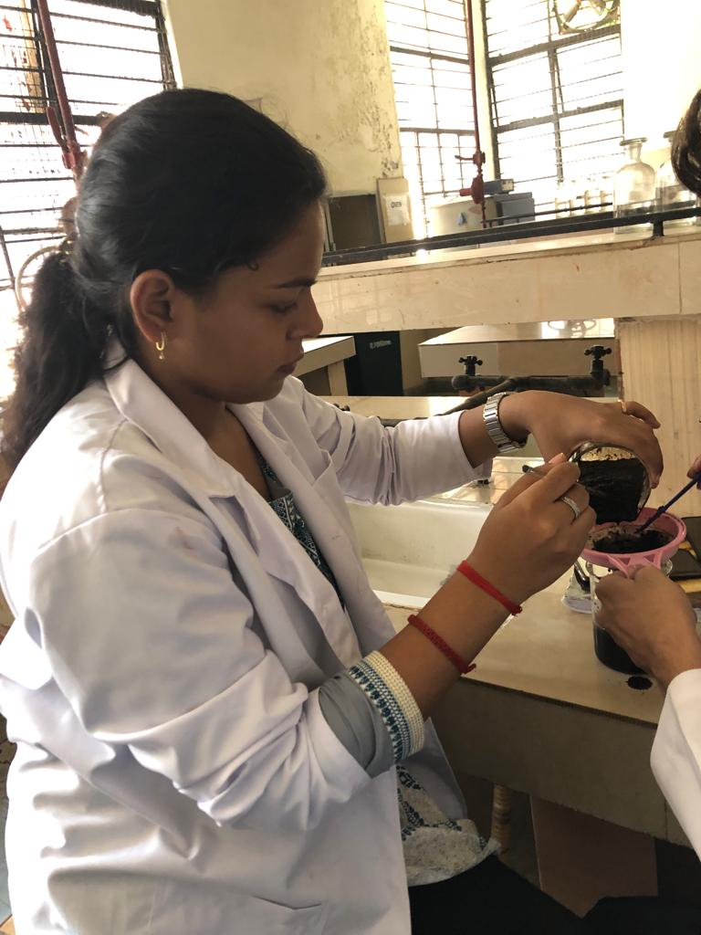
Student extracting caffeine from tea leaves
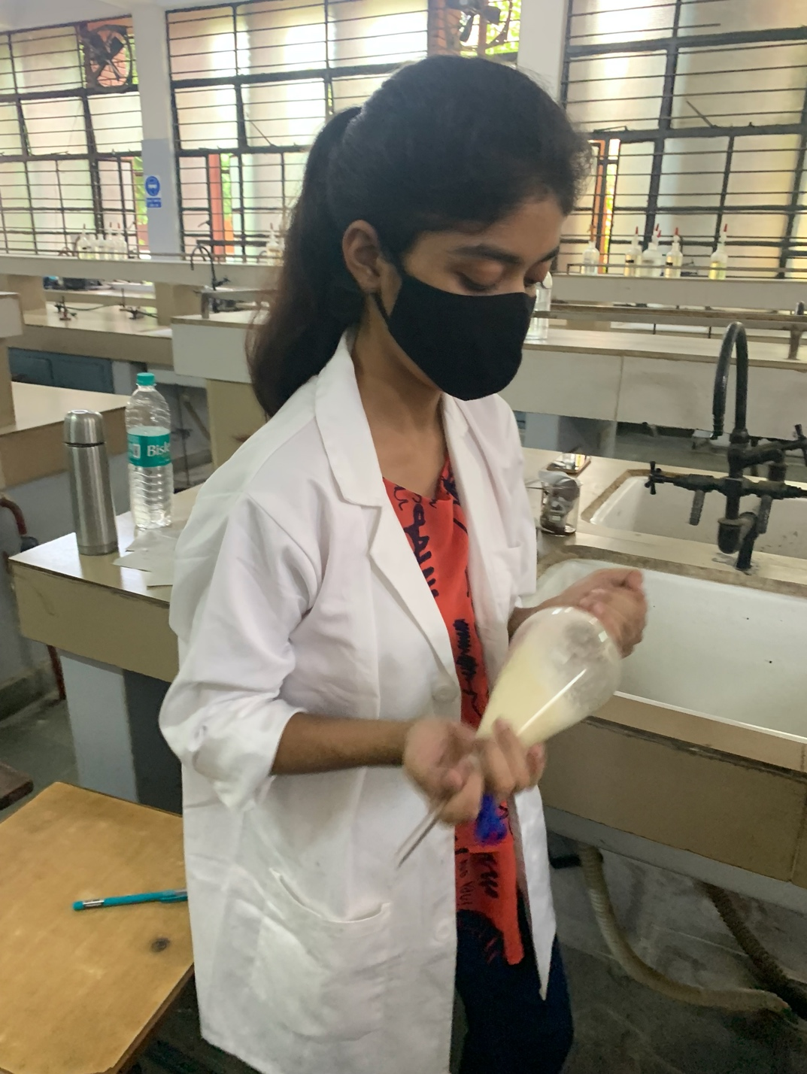
Student using solvent extraction technique

Shivaji College
Department of Zoology
Summer Training Schedule
28th June- 11th July 2022
“Tools and Techniques in Biological Research”

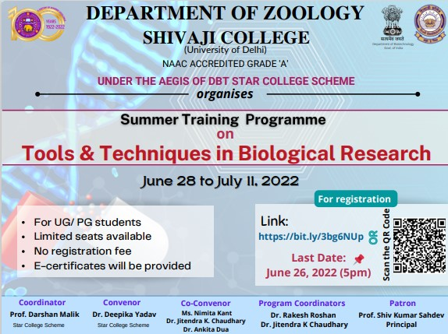

Modules for Summer Training:
- DNA Fingerprinting (Using RFLP & RAPD Techniques)
- Population Genetics
- SDS PAGE for estimation of molecular weight of Protein
- Molecular evaluation of nucleotide sequences using Distance Matrix and Metamethod
- Descriptive statistics and Data Representation

Around 45 U.G. and P.G. students applied and 31 participants successfully completed the training. Participation was received from various disciplines viz. Biomedical Sciences, Microbiology, Life Science, Zoology from PAN India (National Institute of Technology Rourkela, Orrisa, Amity University, Jaipur, Galgotias University, Greater Noida, Bhaskaracharya College DU, Department of Zoology etc.

Resource Persons:
Dr. Sunita Gupta, Dr. Deepika Yadav, Mr. Manish K Sachdeva, Dr. Aeshna Nigam, Dr. Jitendra K Chaudhary, Dr. Ankita Dua, Dr. Neetu Singh, Dr. Nidhi Garg, Dr. Rakesh Roshan & Dr. Tsewang Namgial.

LIST OF PARTICIPANTS

S.NO. | NAME OF STUDENT | COURSE | SEMESTER | NAME OF INSTITUTE
1. | Kamal | B.Sc. (H) Zoology | II | Shivaji College, New Delhi
2. | Harshita Gupta | B.Sc. (H) Zoology | II | Shivaji College, New Delhi
3. | Himanshu Kaushik | B.Sc. (H) Zoology | II | Shivaji College, New Delhi
4. | Ujjwal Goel | B.Sc. (H) Zoology | II | Shivaji College, New Delhi
5. | Harsh Jangid | B.Sc. (H) Zoology | II | Shivaji College, New Delhi
6. | Supriya Bhardwaj | B.Sc. (H) Zoology | II | Shivaji College, New Delhi
7. | Geetanjali Dhunna | B.Sc. (H) Zoology | II | Shivaji College, New Delhi
8. | Anushka | B.Sc. (H) Zoology | II | Shivaji College, New Delhi
9. | Sanjana | B.Sc. (H) Zoology | II | Shivaji College, New Delhi
10. | Priya Roy | B.Sc. (H) Zoology | II | Shivaji College, New Delhi
11. | Isha | B.Sc. (H) Zoology | II | Shivaji College, New Delhi
12. | Taskeen | B.Sc. (H) Zoology | IV | Shivaji College, New Delhi
13. | Mohit Deswal | B.Sc. (H) Zoology | IV | Shivaji College, New Delhi
14. | Sakshi Saini | B.Sc. (H) Zoology | IV | Shivaji College, New Delhi
15. | Sushant | B.Sc. (H) Zoology | IV | Shivaji College, New Delhi
16. | Sparsh Goswami | B.Sc. (H) Zoology | IV | Shivaji College, New Delhi
17. | Radhika | B.Sc. (P) Life Sciences | II | Shivaji College, New Delhi
18. | Mitali | B.Sc. (P) Life Sciences | II | Shivaji College, New Delhi
19. | Anjali Singh | B.Sc. (P) Life Sciences | II | Shivaji College, New Delhi
20. | Yashika Gautam | B.Sc. (P) Life Sciences | II | Shivaji College, New Delhi
21. | Pratibha Jain | B.Sc. Life Sciences | IV | Shivaji College, New Delhi
22. | Shivani | B.Sc. Life Sciences | IV | Shivaji College, New Delhi
23. | Lakshay Vijayi | B.Sc. Life Sciences | IV | Shivaji College, New Delhi
24. | Navya Sharma | B.Sc. (H) Biomedical Sciences | IV | Bhaskaracharya College Of Applied Sciences, New Delhi
25. | Lucky | M.Scc Zoology | IV | Department Of Zoology, Hansraj College
26. | Ritu Tanwar | M. Sc. Microbiology | II | Galgotias University, Greater Noida
27. | Abhishek Choudhary | M.Sc. Microbiology | II | Galgotias University, Greater Noida
28. | Anjali Goswami | M.Sc Microbiology | II | Galgotias University, Greater Noida
29. | Neelam Gautam | M.Sc. Life Sciences | IV | National Institute of Technology Rourkela
30. | Karan Singh | M.Sc. Microbiology | III | NIMS University, Jaipur, Rajasthan
31. | Kajal Jha | B.Sc. Zoology | IV | Shivaji College

Module I:

The first module was held on June 27-29, 2022 and was mentored by Dr. Deepika Yadav, Dr. Aeshna Nigam & Dr. Ankita Dua. The module aim was to enable the students to understand and appreciate the importance of the unique technique of DNA fingerprinting that has extreme value in forensic applications. The assay was done by the approach of restriction fragment length polymorphisms (RFLPs) and Random Amplified Polymorphic DNA (RAPD).

Major equipments the students learnt to handle during the procedures:
- Thermocycler
- Table top centrifuge
- Gel electrophoresis system
- Micropipettes
- Gel domentation system & UV transilluminator

- For the RFLP method, to prepare a fingerprint, a sample of DNA is digested with a restriction endonuclease, the fragments separated by agarose gel electrophoresis, and a Southern blot prepared. A 50ml reaction was prepared with 10ml DNA, 1ml enzyme (Ssp I), 5ml buffer and water to make up volume.
- For the RAPD technique: genomic DNA is denatured, its strands are separated by heating. A synthetic strand of DNA binds to complementary position of genomic DNA. The portion of the DNA after primer is then copied by a molecule of DNA polymerase in a third step called extension. Multiple cycles of steps allow for exponential amplification. Primers can be designed to amplify regions of DNA containing satellites. Products are then separated by gel electrophoresis and a southern blot performed to image DNA bands.
- However, only the first step was accomplished in the laboratory, that is digestion of DNA samples for carrying out RAPD, DNA was amplified using ‘Polymerase Chain Reaction’ from the samples of Serratia marcescens, Bacillus subtilis, E.coli B and E.coli K12. Master mix prepared was made of MQ water, Taq buffer, dNTP mix (10mM), Primer, Taq DNA Pol.

Module IV:

Topic of module IV was ‘Molecular evaluation of nucleotide sequences using Distance matrix and metamethod’. In this module, to study the phylogenetic relationships, participants were able to understand the distance matrix using MEGA software and metamethod using EMBL-EBI site.

Module V:

Statistics encompasses various methods of collecting, summarizing, analyzing, and drawing conclusions from the data. Therefore, it is a prerequisite tool to quantitate and describe the various variables in order to derive a desired meaning and draw any relation. Considering applicability, statistical approaches such as descriptive and inferential are employed in every
conceivable areas of knowledge and across the disciplines. Under the module titled “Descriptive statistics and data representation” of the summer training programme 2022, participating students were trained with regard to meaning and application of statistics through multiple descriptive measures, such as mean, mode, median, range, variance, standard deviation, standard error, etc. In addition, students were also taught about collection and systematic tabulation of data of several qualitative and quantitative variables, as well as graphical representation thereof.

